Standard Operating Procedures
Club Name: Wombourne Kayak Club
Affiliation Type: Unincorporated association
Club Chair Name: Tim Kelly
Number of club members: 29
Open to the Public: Yes at the pool until person has attended 4 sessions.
Contact Details: Tim Kelly: 07817 029118 (Club Website) http://www.wombournekayakclub.co.uk/

https://gopaddling.info/find-paddling-clubs/ Find local paddling clubs
Club Address:
Wombourne Leisure Centre
Ounsdale Road
WOLVERHAMPTON
Postcode: WV5 8BJ
Email: mick@the-obriens.net
Source:
http://www.sportenglandclubmatters.com/club-planning/club-structure/
https://www.britishcanoeing.org.uk/guidance-resources/clubs-centres-providers/clubs/club-management/club-structure
An unincorporated association is particularly well suited to smaller, simpler clubs. This is the most common type of structure for an amateur club, largely because it is the easiest, cheapest and most informal way of forming a club. Typically these clubs would not employ staff, own significant assets (e.g. land, investments or facilities) or enter into significant contracts.
Below are some of the advantages and disadvantages of running a sports club as an unincorporated association:A
- Simple administration. Unincorporated associations (unless also a charity) do not have the same legal and administrative requirements that companies have (e.g. the requirement to file accounts or an annual return).
- Flexible. The rules of an unincorporated association can be whatever they choose, provided they are lawful, and can be easily updated. Remember the rules of your governing body, or the requirements for grant funding, may need your Constitution to contain certain clauses.

include:
- No separate legal identity. An unincorporated association is not separated from its members in the eyes of the law. This means committee members will have to enter into contracts, or hold assets, on behalf of the club, rather than the club itself. In the event of a claim against the club or breach of contract members of the committee, or wider club could be personally liable. If you want to enter into contracts, then you need to consider becoming Incorporated.
- Transfer of assets. As assets are held by individuals on behalf of the club, rather than the club itself, they must be transferred if that person leaves the club.

British Canoeing Membership Status
We want to ensure that all club members have at least a minimum level of third party insurance and that all members of a club affiliated to British Canoeing are aware of the benefits and limitations of their particular membership category. Please note, this is no change to existing requirements. A change regarding a requirement to provide data for all Club Associate Members is outlined in proposal 2.
From October 2020, clubs will be required to provide details of all Club Associate Members, including first name, surname, date of birth, gender, email address (except Juniors) and postcode. We will be working with clubs in the next few months to identify the best way of transferring this information. We will also be providing clubs with guidance on ensuring compliance with all GDPR regulations.

Membership Category
On the Water
For club members who have their own boats or who are paddling outside of club activities. This provides a personal waterways licence and third party liability insurance whilst engaged in any paddling activities. Anyone coaching, leading or instructing activities in your club should also be an ‘On the Water’ member in order to be insured;
Benefits:
- Waterways licence for 4500km of waterways
- Liability insurance for all paddling
- Liability insurance for coaching, leading and instructing
- Monthly newsletters covering events, paddler news, and guidance
- Special member offers and discounts
- Up to 50% off personal performance awards
- 20% off subscription to The Paddler & SUP magazine
- Craft insurance
- Access to competitions
- Access to coaching qualifications
- Voting rights at general meetings

On the Bank
You may be a club member that does not paddle but still contributes to your club in other ways, such as volunteering their time or officiating at events. An ‘On the Bank’ membership allows those who do not paddle but are still involved in the club to be covered for On the Bank insurance and still feel part of the British Canoeing community with voting rights, offers and communications.

Benefits:
- Liability insurance for volunteering or officiating from the bank
- Monthly member newsletters covering events, paddler news and guidance
- Access qualification record and event booking through their membership account
- Access to member discounts and offers promoted through the members news
- Club voting rights at general meetings
Club Associate
This provides third party liability insurance for club activities as defined below;

Benefits:
- Liability Insurance for club session, activities and trips
- Monthly update with news, events, offers and club services
Health and Safety (Policy)

Please detail your clubs Safety Policy and attach to this document. There are three main headings recommended for a policy statement: General Statement of Policy, Organisation and Responsibilities for carrying out the policy and Arrangements for ensuring safety and health of members.

HEALTH AND SAFETY POLICY STATEMENT:

“Wombourne Kayak Club” is strongly committed to encouraging our members to take part, but the health, well-being and safety of each individual is always our paramount concern. We recommend levels of training dependent on age and ability, and expect our junior athletes to participate within these boundaries.”
HEALTH AND SAFETY POLICY:

To support our Health and Safety policy statement we are committed to the following duties:

- Undertake regular, recorded risk assessment of the club premises and all activities undertaken by the club.
- Create a safe environment by putting health and safety measures in place as identified by the assessment.
- Ensure that all members are given the appropriate level of training and competition by regularly assessing individual ability dependant on age, maturity and development.
- Ensure that all members are aware of, understand and follow the club’s health and safety policy.
- Appoint a competent club member to assist with health and safety responsibilities.
- Ensure that normal operating procedures and emergency operating procedures are in place and known by all members.
- Provide access to adequate first aid facilities, telephone and qualified first aider at all times.
- Report any injuries or accidents sustained during any club activity or whilst on the club premises.
- Ensure that the implementation of the policy is reviewed regularly and monitored for effectiveness.

AS A CLUB MEMBER YOU HAVE A DUTY TO:

- Take reasonable care for your own health, safety, and that of others who may be affected by what you do or not do.
- Co-operate with the club on health and safety issues.
- Correctly use all equipment provided by the club.
- Not interfere with or misuse anything provided for your health, safety or welfare.

CLUB HEALTH AND SAFETY OFFICER: Tim Kelly, John Teuwen
FIRST AID: Location of first aid facilities at Pool, Location of telephones: Pool: Leisure Office, See p6

QUALIFIED FIRST AIDERS:
- Pool: Life guards on duty
- Club: Rich Dowen, Tim Kelly, John Teuwen, Dave Bennett, Nigel Lunn, Paul Elkington, Simon Binks, Jonathan Edwards, Jack Richards, David Allen
Organisation, Responsibilities and Arrangements

The “Organisation” and “Responsibilities” for carrying out the policy and “Arrangements” for ensuring safety and health of members are linked to the sourced documents.
Source:
Safety Guidance Document: https://www.britishcanoeing.org.uk/uploads/commonUploads/British-Canoeing-Safety-Guidance.pdf
See Section 5 British Canoeing Checklist – Clubs & Activities (Planning a trip)
Paddle Safer Guidance - https://www.britishcanoeing.org.uk/uploads/documents/Paddlesafer-V3.pdf

Carry out: An annual Audit based on the Section 5 - British Canoeing Checklist for all activities of members p37-49:
- Members Protection
- Planning
- People
- Equipment
- Recording and Reporting of Incidents
- Other Requirements
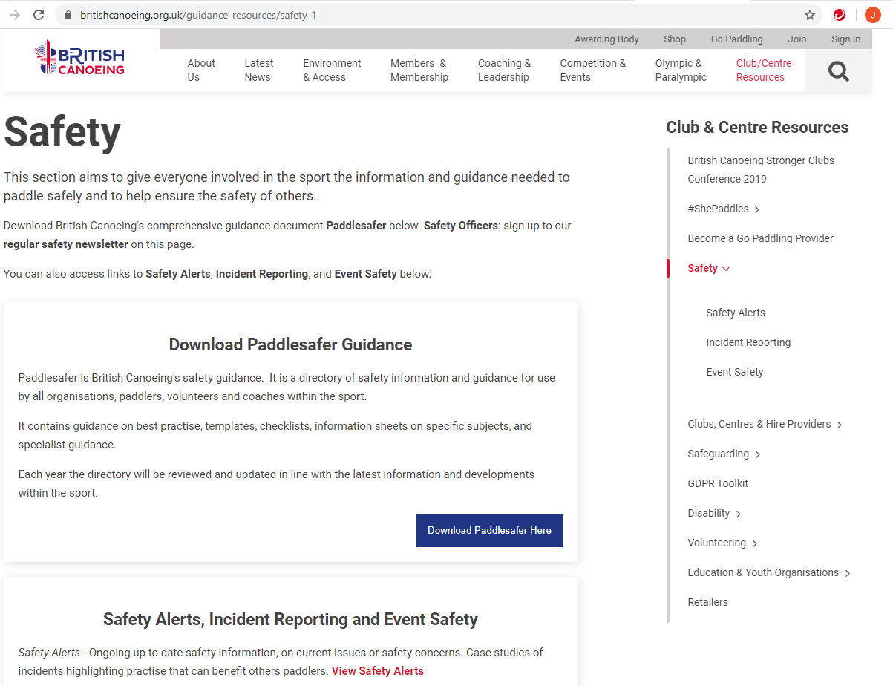
Use: Bibliographical References for polices, document templates & guidance notes, which can be found on Wombourne Kayak Club Website.
Be Aware: Safety Alerts Updates: https://www.britishcanoeing.org.uk/guidance-resources/safety-1
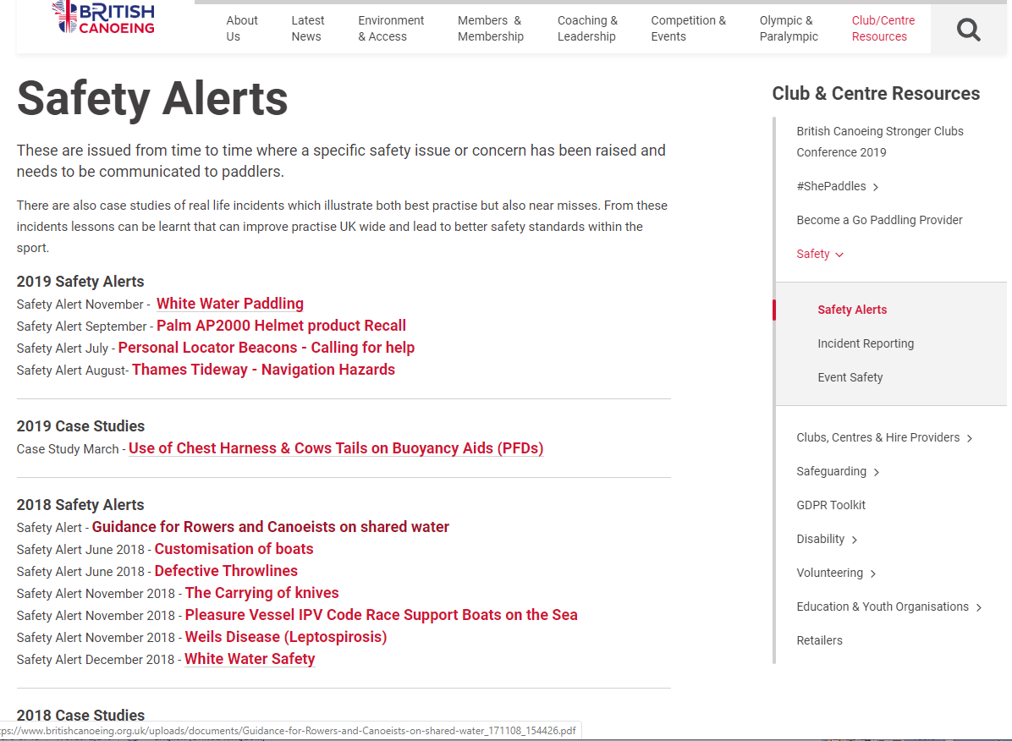
Planning a Trip
A Definition of Club Activities
This definition is provided as a result of requests from clubs for a clear definition of “club activity”. This is no change to existing guidance but assists in defining what paddling activities are covered by British Canoeing third party liability insurance for Club Associate Members.
See Insurance information https://www.britishcanoeing.org.uk/membership/why-join-british-canoeing/insurance-towergate
“Club Associate Members are covered for third party liability insurance for any paddling activity within their club that has had due diligence/risk assessment carried out by the relevant and accountable club representative(s) and is organised and delivered by club members (or others appointed by the committee) for club members and promoted on the official club calendar, website, social media or noticeboard”
“Club activities can also include inter-club activities (involving no more than 4 clubs) where one club (host club) is responsible for risk assessment, management of the activity and sharing this information with the other clubs who take part, providing all clubs involved recognise it as part of their official club activities” (see above definition)
It should be noted that “peer paddles”, independent paddling and competitive paddling are not included. Individuals taking part in these activities are recommended to join as full members of British Canoeing or seek alternative insurance arrangements.
Source:
See British Canoeing Safety Guidelines for Paddlers, Clubs & Volunteers; Section 5 - British Canoeing Checklist – Clubs & Activities (Planning a trip) using the listed sources.

- Section 2 – Planning - 2.1 (a), (b), (c) 2.2
- Section 3 – People - 3.1, 3.2, 3.3, 3.4, 3.5, 3.6, 3.7, 3.8
- Section 4 – Equipment – 4.1, 4.2, 4.3, 4.4, 4.5, 4.6, 4.7
- Section 6 – Other requirements – 6.1, 6.2, 6.3
Wombourne Kayak Club Website http://www.wombournekayakclub.co.uk/ Health & Safety

First Aid & Accidents
Where are the first aid kit and accident book located?
Pool: Lifeguard attending the session has a 1st Aid Kit at hand and in the Leisure Centre Office
River Trips: Each coach carries a 1st aid kit, depending on the location, e.g. Jackfields located in vehicle in the car park. On river trips paddlers designate a person to carry 1st aid & other essential kit in group’s boats.
Who is the main contact for First Aid at the club?
Each river trip will have a designated leader, however within paddling groups will be coaches at different levels with appropriate and current 1st aid training.
Where can the contact be located?
As part of the Emergency Plan, a designated person is contacted to inform when “On & Off” river to ensure appropriate support, e.g. Emergency services can be contacted if required or designated leader has a phone and automatic “Text” to contact them.
Who is responsible for the maintenance of the first aid box?
Each coach is responsible for their own personal kit on river trips; however at the pool the Centre Manager manages the maintenance of the 1st Aid.
Who else is responsible for providing First Aid?
Pool: Centre Manager
River Trips: Individual coaches & members: Rich Dowen, John Teuwen, Simon Binks, Tim Kelly, Paul Elkington, Jonathan Edwards, David Allen, Nigel Lunn, Rob Stewart, Rob Phillips
Is there a document in the club to detail who can provide First Aid?
Pool: Centre Manager
River Trips: Individual coaches, however as part of the club routine paddlers check who is providing the necessary 1st aid and other essential kit.
Source:
Guidance for Paddlers and Pool Managers – copy to Centre Manager. http://www.wombournekayakclub.co.uk/ See Safety Rules
See Paddlesafe p19-24
1st Aid guidance
SECTION 4 - HEALTH AND MEDICAL CONDITIONS
4.1 First Aid
4.1.1 e-learning activity – first aid
https://www.britishcanoeingawarding.org.uk/knowledge-bytes-introduction-to-first-aid-elearning/?utm_source=emailCampaign&utm_medium=email&utm_campaign=Club%20Mailing%20April%202018&utm_content
First Aid Kit https://www.britishcanoeing.org.uk/uploads/documents/4-First-aid-requirments.pdf
Fire & Evacuation
Please detail the clubs fire and evacuation procedure (e.g. where is the fire exits, where should members meet once evacuated?)
Pool: Centre Manager, club members are aware of the fire exits & assembly points
Where is the location of fire extinguishers?
Pool: Centre Manager and her staff have overall responsibility.
Who is responsible for maintenance of fire extinguishers?
Pool: Centre Manager
Do you have a signing in sheet to record members inside the premises?
Pool: Centre Manager, no. Although money is collected for using the pool and names are taken.
Who is responsible for the roll call, to ensure no one is missing? (Name/Position)
Pool: Centre or Duty Manager
Where are the Emergency contact details (for all members) kept in case of an emergency?
Emergency contact details (for all members) kept – Mick O’Brien
All members have Next of Kin on Mobile Phones in “Locked” mode.

Emergency Procedures
Source:
See Emergency Plan (Pre-planning & On the Water)
See British Canoeing Safety Guidelines for Paddlers, Clubs & Volunteers; Section 5 - British Canoeing Checklist – Clubs & Activities (Planning a trip)

- Section 2 – Planning 2.1 (a), (b), (c) 2.2
- Section 3 – People 3.1, 3.4
- Section 4 – Equipment 4.4, 4.5
- Section 5 - Reporting & Recording of Incidents - 5.1
Wombourne Kayak Club Website http://www.wombournekayakclub.co.uk/ see Health & Safety
Do you complete Incident/Accident Forms? Yes
Pool: Centre Manager – Yes River Trips: Yes Agreed at AGM March 2020

Complete the Incident Form found on the Wombourne Kayak Club (Club Website) http://www.wombournekayakclub.co.uk/ Inform Tim Kelly: 07817 029118, before we complete the British Canoeing Incident Report Electronic link www.britishcanoeing.org.uk/go-canoeing/incident-reporting
Who is responsible for completing the Incident/Accident Forms?
Pool: Centre Manager – Yes River Trips: Individual coach to be sent to John Teuwen 017960603786 johnteuwen@hotmail.co.uk

How often are the Incident/Accident Forms reviewed? Who are these reviewed by? Pool: Centre Manager – Yes River Trips: Yes after each incident/Accident

Note: It is usually best practice for the forms to be reviewed by the Club Committee and copies should be forwarded to British Canoeing for insurance reasons

How long are forms kept on record for within the club? Forms should be kept in excess of five years!
Pool: Centre Manager – Yes River Trips: Yes – Agreed at AGM March 2020

Name of designated British Canoeing expert to help with enquiries:
River Trips: Tim Kelly 07817 029118
Note: In the event of a serious incident, what instructions are there with respect to dealing with the media? Club coaches must NOT discuss any event with the press or admit liability to any party
Complete the Incident Form found on the Wombourne Kayak Club (Club Website) http://www.wombournekayakclub.co.uk/ Inform Tim Kelly: 07817 029118, before we complete the British Canoeing Incident Report Electronic link www.britishcanoeing.org.uk/go-canoeing/incident-reporting

Discipline

Please outline the clubs policy in regards to bad behaviour, infringement of the rules etc.? Some clubs operate a three-strikes-and-you’re-out response. In these cases, the individual or parent/guardian shall be informed of each strike in writing from the Club Chair. In some instances it may be necessary to ban a member at the first infringement for the safety of club members or in the interest of the clubs reputation

Source:

Club Constitution http://www.wombournekayakclub.co.uk/constitution/ 2020, includes Governance & Roles. Explanation of roles: https://www.britishcanoeing.org.uk/guidance-resources/clubs-centres-providers/clubs/club-management/governance-roles

Paddlesafe - SECTION 1 - CULTURE AND PRACTICE

  - Safety Culture and Duty of Care, See Codes of Conduct http://www.wombournekayakclub.co.uk/
https://www.britishcanoeing.org.uk/uploads/documents/1-Duty-of-Care.pdf

British Canoeing Code of Ethics

Code/s of Conduct:
T2 Junior
T3 Adult
T4 Paddlesport Trip Consent Form (Under 18)
T4 a Paddlesport Trip Consent Form (Adult)
G5 Codes of Conduct for Coaches
G9 (BC) Paddlesafe Away Trips, if not accompanied by Parent or Guardian.

See Safeguarding Section p10-11 for policies, guidance & documents

Safeguarding

Non-members/ Visitors:
To be supervised by designated person delegated by member of the Committee.
What are the clubs policies regarding non-members or visitors in the changing room facilities?
Public changing room! To be supervised by designated person delegated by member of the Committee.
Children will not be permitted to leave the centre without the knowledge or permission of the Coach.
Start time is late 9.30pm and usually parents attend session.
Unknown person(s) picking up a child should make themselves known to the Coach on arrival of dropping the child at the centre.
Start time is late 9.30pm and usually parents attend session.
Club Child Protection and Vulnerable Adults Policy
Policy to be reviewed along with other documents
Does the club have a Child Welfare Officer? Yes
If yes, please detail Name and Contact details:
John Teuwen Phone: 07960603786 Email: johnteuwen@hotmail.co.uk
How often is this Policy reviewed? This Policy is reviewed annually
Sources:
Paddlesafe - 3.13 Safeguarding

British Canoeing Policies, Procedures, Guidance, Templates, Guidance link https://www.britishcanoeing.org.uk/guidance-resources/safeguarding/policies-guidance-and-templates

British Canoeing Safeguarding page link https://www.britishcanoeing.org.uk/guidance-resources/safeguarding
Safeguarding – See British Canoeing Safety Guidelines for Paddlers, Clubs & Volunteers; Section 5 - British Canoeing Checklist – Clubs & Activities (Planning a trip)

Section 1 – Protection - 1.1, 1.2

Club Equipment

Please detail who is responsible for logging equipment and routinely safety checks? John Teuwen, Paul Elkington
Source: See British Canoeing Safety Guidelines for Paddlers, Clubs & Volunteers; Section 5 - British Canoeing Checklist – Clubs & Activities (Planning a trip)

- Section 4 – Equipment – 4.1, 4.2, 4.3, 4.4, 4.5, 4.6, 4.7
- Section 6 – Other requirements – 6.1, 6.2, 6.3
Wombourne Kayak Club Website http://www.wombournekayakclub.co.uk/
Who can use club equipment and when?
Pool: Designated coaches & club members River Trips: Designated coaches & club members
What are the requirements for non-members using the equipment? (E.g. school groups)
Not applicable
Can club equipment be taken off site for use?
River Trips: Designated coaches organise & allocate to club members
How and where should equipment be stored?
River Trips: Collected from Leisure Centre, individual personal equipment is loaned to paddlers.
How are faults reported and recorded?
Paul Elkington will report to the Committee.
Keys
Who opens up? (E.g. Officials, Club members) Pool: Boats, centre staff,
Who locks up? Pool: Designated coach to put “Cage” kit away, individual club members to put boats away.
What are the rules for locking the Club at the end of the day? Pool: Centre Duty Manager & staff
Where are keys kept? Pool: Centre Duty Manager & staff

Who has keys/access to keys? (E.g. Captains, Coaches)
Pool: Centre Duty Manager & staff,

Where are spare keys kept (if any)? None

Where are the keys to equipment stores kept (if any)? None

Declaration
Wombourne Kayak Club hereby adopts and accepts this as a current operating guide regulating the actions of members. Electronically signed.

Name | Tim Kelly |  | Position | Chair
Sign | 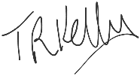 |  | Date | 15/07/2021
Name | Rich Dowen |  | Position | Vice Chair
Sign | Rich Dowen |  | Date | 27/07/21
Name | Mick O’Brien, Note Paul Elkington to take over role; signed signatures: J.Teuwen, Paul Elkington, Tim Kelly  Paul Elkington |  | Position | Treasurer
Sign | John Teuwen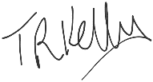 |  | Date | 5/07/2021
Name | John Teuwen |  | Position | Welfare
Sign | John Teuwen |  | Date | 5/07/2021
Name | John Teuwen, Tim Kelly |  | Position | Health & Safety
Sign | John Teuwen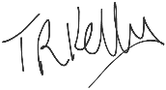 |  | Date | 15/07/2021
Name |  | Paul Elkington | Position | Equipment
Sign |  | Paul Elkington | Date | 26/07/2021
Name |  | Paul Elkington | Position | Media Publicity
Sign |  | Paul Elkington | Date | 26/07/2021
Name |  | Rich Dowen | Position | Events Trips Organiser
Sign |  | Rich Dowen | Date | 27/07/21
Name |  | John Teuwen | Position | Coaching Coordinator
Sign |  | John Teuwen | Date | 15/07/2021
Name |  | John Teuwen | Position | Website
Sign |  | John Teuwen | Date | 15/07/2021
Name |  | John Teuwen | Position | Secretary
Sign |  | John Teuwen | Date | 15/07/2021

