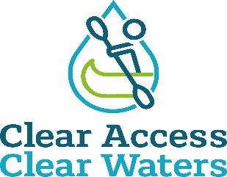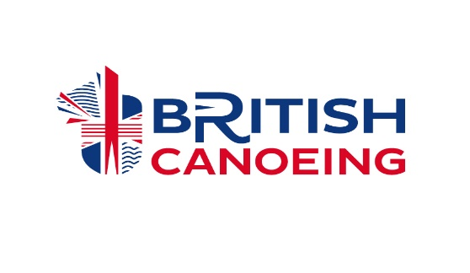

Dale End Car Park - Ironbridge

British Canoeing has been made aware by the paddling community that an access point at Dale End Carpark to the River Severn used by paddlers of all ages, abilities and interests, for many decades, is being restricted. It is also of great interest to touring paddlers who love the world famous Ironbridge.

British Canoeing has met with and formally written to the landowner twice, however the landowner remained fixed in their view.

The next step continues to be investigation locally for evidence of use in order to make a claim for a right of way based on public use, the law (section 31 of the Highways Act 1980) requires that you’re able to meet the following criteria:

- A period of at least 20 years' uninterrupted use by the public (this is the public as a whole, not just one person, though applications where single users have used the route for 20+ years is stronger) from the date it was brought into question.
- Use must be 'as of right', which means without secrecy, force, or the express permission of the landowner
- Use must be by the public at large, not just certain tenants or employees of an estate
- From a public highway (in this case Telford and Wrekin Council have now confirmed that Definitive Public Footpath 81 runs close to the access points in question, along the tarmac pathway), along a specified route. It is important to note that users may have used a number of slightly different routes, which may have changed over time due to one reason or another, so user maps accompanying evidence needs to be clear on the precise route taken. A review of the evidence will then be undertaken by British Canoeing and the lead volunteer in liaison with Telford and Wrekin Council with the intention of submitting an application for the Definitive Map to be modified to the council.

This is being co-ordinated by a new lead volunteer John Teuwen to establish if public rights exist, with support from British Canoeing.

In order to secure access at The River Severn it is absolutely essential that anyone who has used the route on a fairly regular basis to access the river and who meets the above criteria, should complete a user evidence form and accompanying map showing the route(s) used. It is also essential to understand the evidence may be used at a Public Inquiry so please do consider all questions thoroughly. Completed evidence forms and accompanying plans should be emailed to access@britishcanoeing.org.uk clearly titled ‘User Evidence – Dale End - Ironbridge’ or posted to Chantelle Grundy, British Canoeing, Adbolton Lane, Holme Pierrepont, Nottingham, NG12 2LU.

British Canoeing is committed to protecting and enhancing places to paddle as detailed in our Access and Environment Charter - Clear Access Clear Waters . British Canoeing will continue to work towards retaining this location as a launch spot which has been used respectfully and responsibly by paddlers over the years.

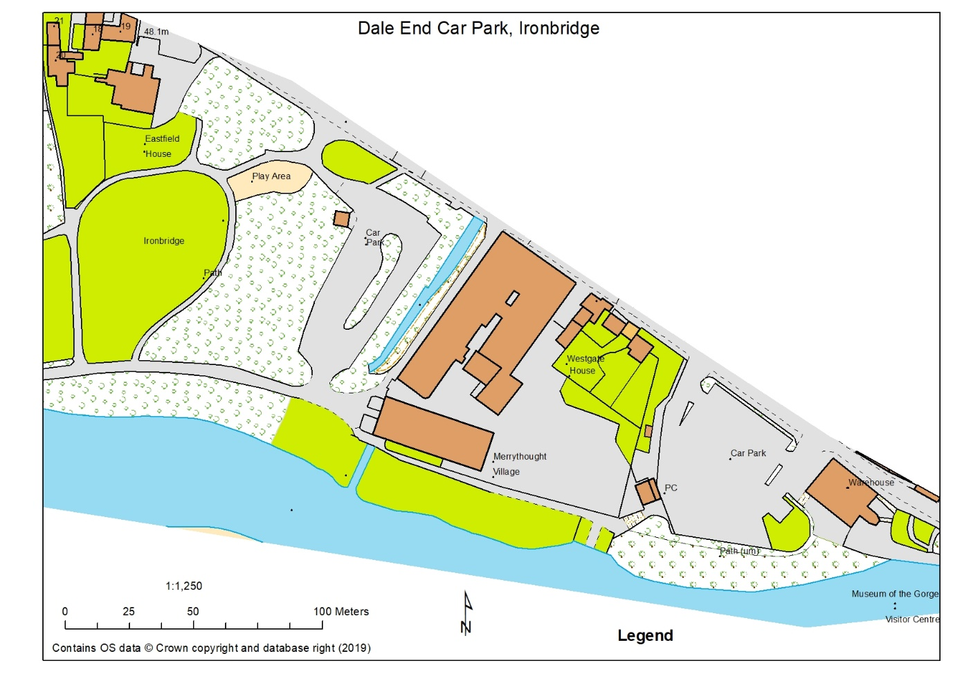

Plan of area provided by D Bennett. Note: Merrythought Village Company (Teddy bears) own the river bank for a 100m from the River Cole running along the “Car Park” into Dale End Park.

66 67

04

03

666038 Dale End Long Stay Car Park

