The process of making a Definitive Map Modification Order (DMMO) or in layman’s terms “Access” to a river issue
Access to the river is denied!
E.g. access/egress point used over a number of years by paddlers such as 20 years +
Contact British Canoeing Regional Development Team Area (RDT) Representative
No response or action!
Contact British Canoeing Regional Development Team Chair

No response or action!
Contact British Canoeing
Chantelle Grundy Access & Environment Officer, Places to Paddle
Tel: 01158968837
Mobile: 07794051286
Email: chantelle.grundy@britishcanoeing.org.uk

Challenging Issues:
- RDT are volunteers & have limited time to address issue.
- British Canoeing staff has a huge “Workload” and limited time to address each issue.
- As a result “No” action taken, it may be necessary to inform organisational hierarchy as a last resort!
Action:
- It is extremely important to establish a local paddler (Retired person) with time to co-ordinate.
- Create a questionnaire. Ask Chantelle for the one on file used for Ironbridge – see Appendix 1
- Obtain a OS Data Map. - see Appendix 2
- Set up a “Digital” brief and link to questionnaire & map – see Appendix 3 & 4 by British Canoeing in order to publicize the “Access” issue nationally and for evidence respondents to post back. Over 20 years usage of access point is essential for (DMMO)
- Contact British Canoeing Regional Development Team Chair to inform of action and request them to contact & inform local clubs of action.
- Contact local paddler Network and clubs by email, text, messenger or phone to inform them of current situation.(Email link)
- Create a spreadsheet to monitor progress; who’s been contacted by whom, what respondents have returned evident, how many years have they used the location, e.g. more than 20+
- Follow up previous communication with respondents that have not returned evidence.
- Sufficient evidence gathered, British Canoeing to prepare (DMMO) and checked by their solicitors before sending to Council and landowner involved in the Access Issue.
- Letter sent by British Canoeing to thank evidence contributors and keep them updated with progress.

Appendices
Appendix 1

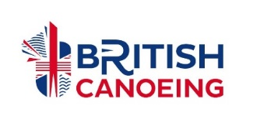
PUBLIC RIGHT OF WAY USER EVIDENCE STATEMENT
This statement is intended to provide preliminary evidence about the application to establish whether or not the route being claimed in the application is a public right of way. Once completed please return your signed statement to British Canoeing who will submit the application on your behalf to your local surveying authority, who may contact you to seek further information. It is possible you may be asked to attend a public inquiry to clarify your evidence. Please complete one form per person per route. Please return to access@britishcanoeing.org.uk or FAO Access and Environment Officer, British Canoeing, National Watersports Centre, Adbolton Lane, Holme Pierrepont, Nottingham, NG12 2LU

Data Protection

British Canoeing is a privacy conscious organisation and is strongly committed to an individual’s right to privacy. All data provided during the completion of this form (other than your personal contact details), will be utilised for the purposes of gathering information regarding, and evidencing the existence of, Public Rights of Way. You should provide us with the information requested only if you are happy for it to be placed in the public domain. Do not include personal information about another person. Any personal data will be processed and stored in compliance with the British Canoeing Data Protection Policy and in accordance with all applicable Data Protection laws in effect at the time of publication of this form, including but not limited to, the Data Protection Act 2018 and the GDPR which came into effect on 25th May 2018. The information gathered may be shared with third parties including, but not limited to, the local surveying authority for the area, the Planning Inspectorate and other government departments dealing with the processing of the order once an application is made.

Further information on British Canoeing’s approach to privacy and data protection, including our privacy notices, policies and contact details, can be located in our Privacy Centre (https://www.britishcanoeing.org.uk/about/privacy-centre). Should you wish any data we hold relating to you to be deleted at any point, you should contact us at GDPR@britishcanoeing.org.uk.

Please tick this box to acknowledge that you have read and understood this Data Protection section □
Name …………………………………………………………………………………………….........
Address …………………………………………………………………………………….
Post Code ………………………….
Year of birth ……………………………………………………………………………………………
Contact telephone number …………………………………………………………………………..
Email address …………………………………………………………………………………………
Please note your personal contact details will not be placed in the public domain.
Statement of Truth
(all witnesses must complete this statement)
I BELIEVE THAT THE FACTS AND THE MATTERS CONTAINED IN THIS STATEMENT ARE TRUE AND I HAVE READ THE DECLARATION ABOVE
Signature (of the person making the truth): ……………………………………………………..
(If applicable) Signature of person taking this statement: …………………………………….
Print full name: ……………………………………………………………………………………..
Date: …………………………………………………………………………………………………
You should keep a copy of the completed statement
Warning: If you dishonestly enter information or make a statement that you know is, or might be, untrue or misleading, and intend by doing so to make a gain for yourself or another person, or to cause loss or the risk of loss to another person, you may commit the offence of fraud under section 1 of the Fraud Act 2006, the maximum penalty of which is 10 years’ imprisonment or an unlimited fine or both.

Your Name ………………………………………………………………………….

Please describe the route:

From ……………………………………………………………….. (Grid reference)

To ………………………………………………………………….. (Grid reference)
Please attach an extract map of your choice and identify the route you have used with a precise line and annotate any additional detail you refer to in your statement; such as a gate, notice and then sign and date it.

1. In which years did you use the application route?

From……………………………………….. To………………………………………………….

2. Were there any extended periods during which you did not use the route at all? If so, please state when and why?

……………………………………………………………………………………………………….

3. Where were you going to and from?

………………………………………………………………………………………………………..

4. For what purpose?

………………………………………………………………………………………………………..

5. How many times a year?

………………………………………………………………………………………………………..

6. By what means (eg on foot, on horseback)?

………………………………………………………………………………………………………..

7. Has the way always run over the same route? If not, give details and dates of any changes.

…………………………………………………………………………

8. Approximately how wide is the application route?

…………………………………………………………………………

9. Have there ever been any of the following on the application route?
- Stiles [How long were they in place? State locations and show on your map]
……………………………………………………………………………………………
- Gates [How long were they in place? State locations, indicate if locked and show on your map]
……………………………………………………………………………………………
- Other barriers [How long were they in place? State locations and show on your map]
……………………………………………………………………………………………

- Did any of the above prevent you from using the application route?
……………………………………………………………………………………………
- Have you ever seen signs or notices such as ‘Private’…, ‘No Road’, ’No Right of Way’ or ‘Trespassers will be Prosecuted’ on the route? If so, what did the notices say and what period were they there for?
……………………………………………………………………………………………..
- If you were working for any owner or occupier of land crossed by the way at the time when you used it, or were then a tenant of any such owner, give particulars and dates. If not, write ’No…
……………………………………………………………………………………………..

- If so, did you ever receive any instructions from him as to the use of the way by the public? If so, what were they?
………………………………………………………………………………………………..
- Have you ever been stopped or turned back when using this way, or do you know or have you heard of anyone else having been stopped or turned back? If so, state when the interruption took place and give particulars.
……………………………………………………………………………………………..

- Were you ever told by any owner or tenant of the land crossed by the way, or by anyone in their employment, that the way was not public? If so, state when and give particulars and dates.
………………………………………………………………………………………………

- Have you ever asked permission to use the way?
……………………………………………………………………………………………
- Have you seen other people using the application route whilst you have been using it?
……………………………………………………………………………………………
- Have you ever had a private right to use the application route? (for example, an easement, private right of access, licence, etc)
……………………………………………………………………………………………
- Do you have, or do you have knowledge of, any documentary evidence which is relevant to the application route or which indicates public use? (for example photographs, guidebooks
……………………………………………………………………………………………

- Should you wish to provide additional evidence please attach to this statement, sign and date.
……………………………………………………………………………………………

I am/am not willing to attend a hearing, public inquiry or court to give evidence on this matter, if this should prove to be necessary [please delete as appropriate].

I hereby certify that to the best of my knowledge and belief the facts that I have stated are true.

Signature …………………………………………………………
Date …………………………………………………………

Appendix 2
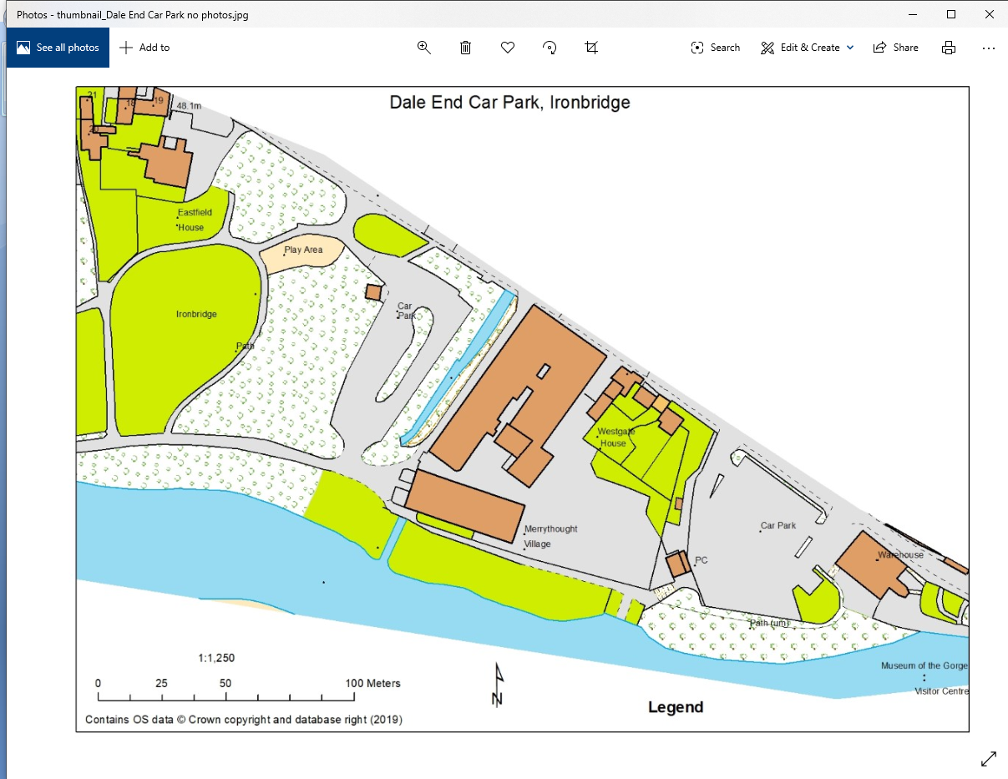
Appendix 3

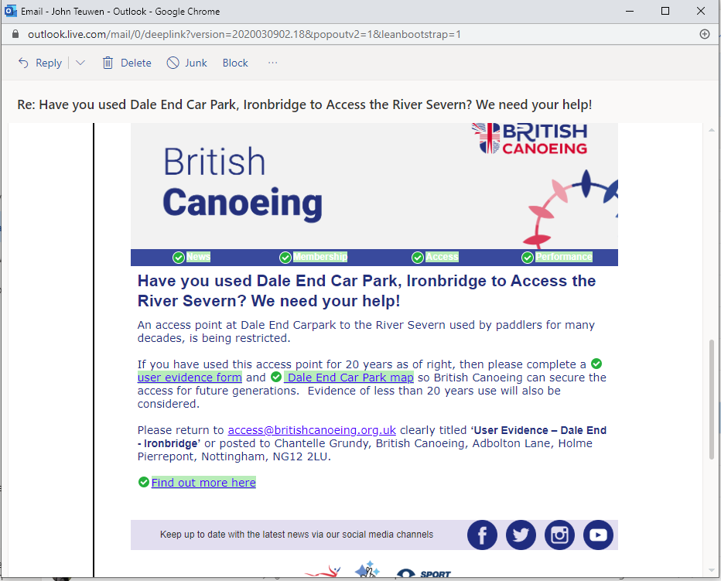
Appendix 4
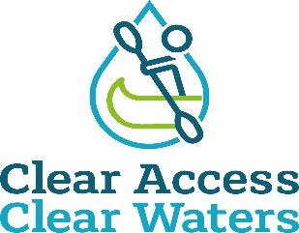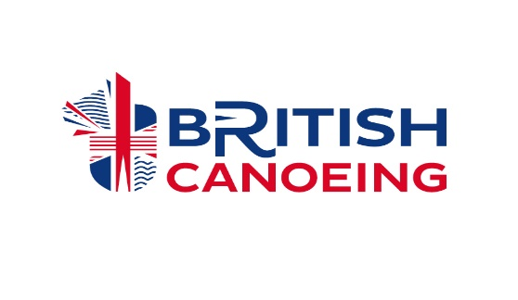

Dale End Car Park - Ironbridge
British Canoeing has been made aware by the paddling community that an access point at Dale End Carpark to the River Severn used by paddlers of all ages, abilities and interests, for many decades, is being restricted. It is also of great interest to touring paddlers who love the world famous Ironbridge.
British Canoeing has met with and formally written to the landowner twice, however the landowner remained fixed in their view.
The next step continues to be investigation locally for evidence of use in order to make a claim for a right of way based on public use, the law (section 31 of the Highways Act 1980) requires that you’re able to meet the following criteria:
- A period of at least 20 years' uninterrupted use by the public (this is the public as a whole, not just one person, though applications where single users have used the route for 20+ years is stronger) from the date it was brought into question.
- Use must be 'as of right', which means without secrecy, force, or the express permission of the landowner
- Use must be by the public at large, not just certain tenants or employees of an estate
- From a public highway (in this case Telford and Wrekin Council have now confirmed that Definitive Public Footpath 81 runs close to the access points in question, along the tarmac pathway), along a specified route. It is important to note that users may have used a number of slightly different routes, which may have changed over time due to one reason or another, so user maps accompanying evidence needs to be clear on the precise route taken. A review of the evidence will then be undertaken by British Canoeing and the lead volunteer in liaison with Telford and Wrekin Council with the intention of submitting an application for the Definitive Map to be modified to the council.

This is being co-ordinated by a new lead volunteer John Teuwen to establish if public rights exist, with support from British Canoeing.
In order to secure access at The River Severn it is absolutely essential that anyone who has used the route on a fairly regular basis to access the river and who meets the above criteria, should complete a user evidence form and accompanying map showing the route(s) used. It is also essential to understand the evidence may be used at a Public Inquiry so please do consider all questions thoroughly. Completed evidence forms and accompanying plans should be emailed to access@britishcanoeing.org.uk clearly titled ‘User Evidence – Dale End - Ironbridge’ or posted to Chantelle Grundy, British Canoeing, Adbolton Lane, Holme Pierrepont, Nottingham, NG12 2LU.
British Canoeing is committed to protecting and enhancing places to paddle as detailed in our Access and Environment Charter - Clear Access Clear Waters . British Canoeing will continue to work towards retaining this location as a launch spot which has been used respectfully and responsibly by paddlers over the years.

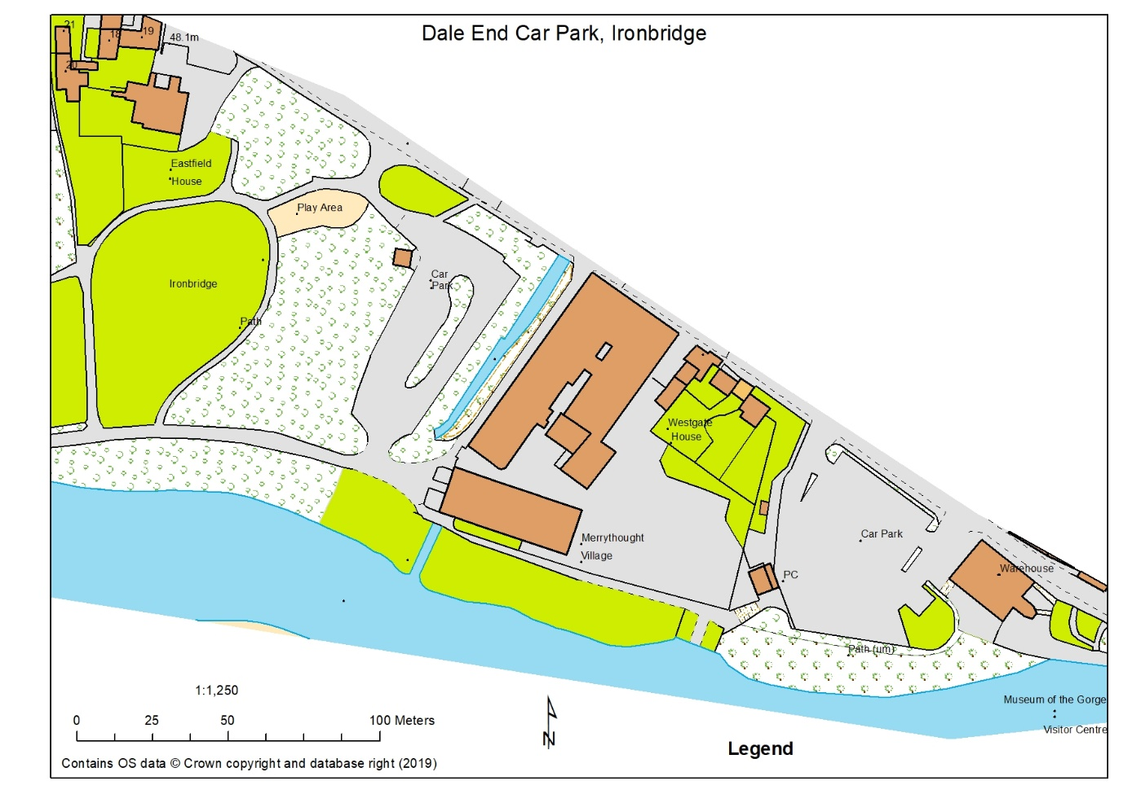

Plan of area provided by D Bennett.

Additional Information
At the present time the ‘how to get involved’ with PROW historic routes affected by the 2026 cut off date is on the main BC website and signposts to BHS and Ramblers projects who are experts in this area and we work very closely with: https://www.britishcanoeing.org.uk/go-canoeing/access-and-environment/projects/public-rights-way

The user evidence based claims which you kindly led on at Ironbridge is here, with an outline of the process of making a Definitive Map Modification Order (DMMO) : https://www.britishcanoeing.org.uk/go-canoeing/access-and-environment/projects/public-rights-way/making-changes-to-the-definitive-map.

