Wombourne Kayak Club Newsletter May 2020
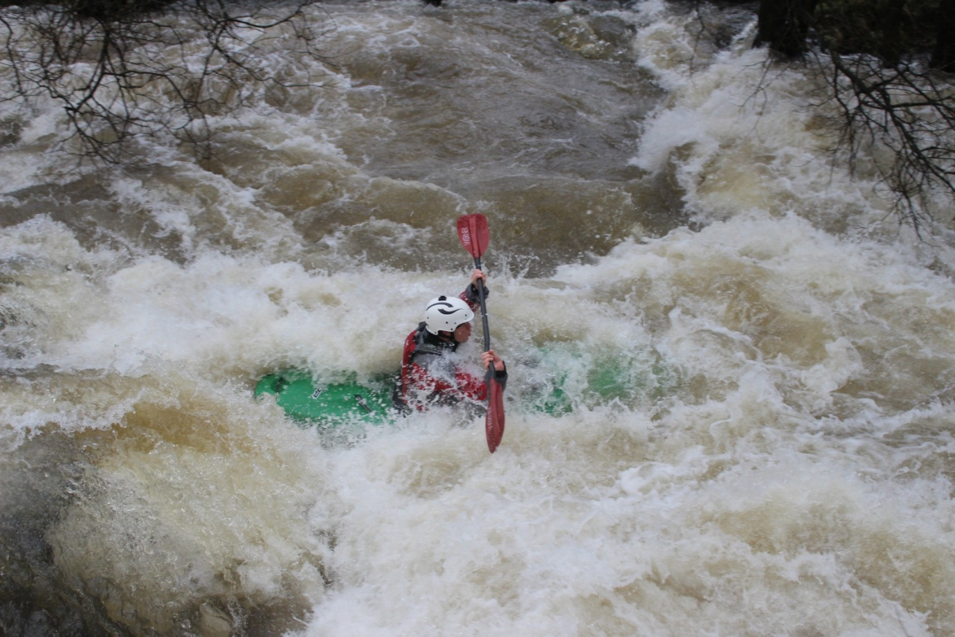

The purpose of the Wombourne Kayak Club Newsletter is to share members’ experiences of river journeys, promote British Canoeing Coaching, Campaigns and news to a wider audience to enable a network of paddlers to share ideas based along the River Severn.

This is our second newsletter in which we find that since the “Lockdown” in March, has prevented any form of paddling taking place. It’s been great that Geoff Lewis has reminded us of previous paddling experiences and adventures, which will help us to remember those great river trips. I hope that the videos and comments from both Rich Dowen and Neil Robinson will remind us of the future adventures we can look forward to participate.
Contents:
- Reflections on recent trips
- Coaching, campaigns and news
- Dates for your diary
- Club notices
RICH DOWEN’S REFLECTIONS ON PAST RIVER TRIPS OVER THE PAST 12-18 MONTHS
John recently asked me a few questions that he thought might be interesting to add to a newsletter. Here is a list of his questions with my responses.

Video links:

River Usk Video

River Gam Video

River Duddon Video
WHAT RIVER TRIP DID YOU ENJOY MOST?
A difficult question to answer as I genuinely enjoy all river trips for a wide range of reasons. Camaraderie, banter, exercise, scenery, wildlife, challenges and seeing places many people aren’t able to get to.
However, 3 trips spring to mind for differing reasons:-
Just over 12 months ago, 16th March 2019 to be precise, Paul, Rob, John, Dave Allen & myself went down to the River Usk for a paddle.
The second trip was when Tim, Paul & I paddled the River Duddon in the lakes on the 28th September 2019.
And the 3rd trip was the River Gam adventure on 26th October 2019 paddled by Rob, Paul and myself.
WHAT WERE THE SAFETY MANAGEMENT ASPECTS DID YOU NEED TO CONSIDER AS THE GROUP LEADER?
As with all club trips the general safety rules apply and the usual check list of kit and equipment is adhered to.
The paddle on the Usk was chosen as we had seen an awful lot of rain fall prior to choosing this river and despite the high level it was deemed the safest bet on the day as it is a wide river which offers many choices of lines and consequently you are able to keep away from stoppers, strainers and trees. Dave Allen chose not to run the river on the day as he decided discretion is the better part of valour, he very kindly offered safety support and ran the shuttle. It is a credit to the club that no one is ever put under pressure to paddle a river or run a feature that are not happy to do of their own choice.
The Duddon trip had been recommended by Mike Haines and conditions have to be just right for the Duddon to run. Tim had this river in mind and had checked out the necessary access and egress points and watched video footage to enable him to get a picture of some of the features we would encounter. So on the River Duddon I was able to enjoy the ride as Tim led the vast majority of the trip and being the most experienced of the group the burden of responsibility defaulted to him as he had done all the research and pre planning.
The Gam trip as we are well aware led to review of the club’s safety policy and techniques and some very useful lessons were learnt. We chose the River Gam on the day over the Ceiriog because we’d all run it before whereas ironically the Ceiriog is known to regularly have a few trees blocking the way and often forcing portages and neither Paul nor Rob had run it previously.
WHAT DID YOU FIND CHALLENGING?
The Usk was in flood when we put on and the water was pushing us along at a much faster rate than it normally would for this run down to Mill Falls. The river being so much higher meant we had difficulty in recognising the features or the level had made the feature a totally new experience and we had to change some of the usual lines of approach. Some of the waves were huge and it was a very big and bouncy experience, almost like paddling a rough sea! We had a couple of swims to deal with and we had to choose safe spots to get water logged boats to the river bank.
The river Duddon was a new trip for all of us and we were aware there were a few grade 3/3+ features and a grade 4 section towards the end of the trip which would offer a different challenge. The Duddon was a river you had to treat with respect for most of the run but a very rewarding paddle in a beautiful area that left you with a real sense of achievement.
The Gam trip became a real learning experience for the 3 of us on the trip but also for the club as a whole. On the day recovering all the boats, paddles and kit and getting us all re-united was a challenge and experience. For myself paddling most of the river on my own in search of boats was both daunting and exciting and without the help of Farmer Gittins things may have been a lot more difficult!
WHAT WENT WELL?
The fact that I thoroughly enjoyed all three trips and any problems we encountered were dealt with as effectively as possible meant we are always learning and improving from our experiences. On the River Duddon, as this was a new river to us all, we did get out and look at and assess a couple of the features prior to running them.
WHAT WAS DIFFERENT FROM YOUR LAST EXPERIENCE ON THIS PARTICULAR RIVER TRIP?
I checked my paddling log to see when I’d previously run the Usk from Tal-y-bont and through Mill Falls. The paddlers were me, John, Geoff & Keelan on February 13th 2016, so it had been a couple of years since running this stretch of river. On the day the gauge at Llandetty was reading 1.17 and I have recorded in my log that the first 2 to 3 kilometres is slow and flat. For the trip in March 2019 the E A gauge at Llandetty was reading 2.8 metres, or to those of us still using imperial language nearly five and a half feet more water. This meant the first 2 to 3 kilometres was quite bouncy and a lot faster and it continued to get faster and the waves a lot bigger as we progressed.
The Duddon was new to us all so we had nothing to compare a previous trip there.
We have always been aware of the fact that the River Gam has always had a problem with overhanging trees and branches. There is no gauge on this river and we have to use the Gauge on the Banwy at Llanerfyl. On a previous trip on 10th March 2018 the Llanerfyl gauge was reading 1.9 and the paddlers were Dave Parocki, Dave Bennett, Rob Stewart and myself. We had no issues that day as the leaves were not yet on the trees so the branches weren’t hanging so low without the weight of the leaves and consequently visibility was a lot better. For the trip in October 2019 the river was nearly a foot higher and the branches were still laden with leaves and hanging a lot lower. This made a huge difference to the amount of clearance or headroom we had. Where we previously we had 3 feet of headroom we were now down to a foot and suffered the inevitable consequences of trying to paddle through trees!
WHAT WOULD YOU DO NEXT TIME? (Based on the club’s current emergency planning)
We are fortunate in the fact that we have a good amount of river knowledge that has been passed between paddlers and local clubs. Every paddle we do whether it is a new river to us or one we have done many times before requires a risk assessment, some of which is done dynamically on arrival at the venue, but most is done prior to leaving home. River levels, time of the year, hours of daylight and expected journey time, weather conditions and appropriate clothing are all things to consider. Who is in the group and is the chosen paddle suitable for everyone are all factors to take into account. Access & egress points, maps, features we may encounter are viewed on Ytube wherever possible. Basic essentials such as food & a drink, first aid kits, throw lines, split paddles, rescue kit are all checked prior to putting on the water. We have recently added additional safety precautions and wherever possible paddlers should now carry their mobile phones in person, what 3 words app added to your phone, knowing other group members telephone numbers and carrying a small amount of cash have all help to make trips as safe as possible.
WHAT PERSONAL DEVELOPMENT HAVE YOU UNDERTAKEN OVER THE LAST 18 MONTHS?
For many reasons it has always been the club’s philosophy to provide good coaching and guidance wherever possible. On 13th & 14th January 2018 Tim & I took our White Water Kayak Leader assessments and managed to complete and pass that course.
On 31st July & 1st August 2018 Me Tim and Oliver did a 2 day White Water Coach training course on the River Dee at Llangollen under the guidance of Coach Dave Kohn-Hollins. On the first day we had a family of Students in Tanya & Andy Neilson and their son Sam. Andy was unable to paddle on the second day of training due to injury and so John Teuwen and Steve Mason volunteered to help out as students. A good training course and we all learnt loads.
On Saturday 27th October 2018 a group of club members consisting of Dave Allen, Rob Stewart, Neil Heath, Jack Richards, Asa Walker and Jonathan Edwards were taking part in a White Water Safety & Rescue Training course with Phil Hadley as their instructor.
I went along to observe, participate and assist Phil even though I’d been on 2 WWSR courses before, it is always good to watch an experienced Coach at work and see the different techniques and methods they use.
Having done the White Water Coach Training, it now seemed like a natural progression and of benefit to the club for Tim & I to do our White Water Kayak Coach assessments which we undertook at Holme Pierrepont on September 5th 2019. Hopefully we are now able to help and assist any new club members to progress their paddling and reach their own goals.
HOW HAS IT HELPED YOUR DECISION MAKING WHEN UNDRETAKING A RIVER LEADER ROLE?
Both the White Water Leader Training & the White Water Coach Training help you improve your own paddling as you have set criteria to reach. You learn how to watch and analyse people’s performance and spot errors or weaknesses where improvements can be made with a little help and encouragement. Hopefully we can help paddlers gain in confidence and improve techniques so they can make good judgement calls for themselves so they are able to relax and enjoy their paddling.
As Leaders and Coaches our decision making and judgement calls should help prevent problems arising, however if a problem does arise we should be better prepared and more confident in dealing with the incidents that do inevitably occur in our sport.

“New Member” personal views of joining Wombourne Kayak Club:

I’m Neil Robinson a 44 year old lorry driver, after spending most of last summer holiday paddling the Pembrokeshire’s coast, my wife insisted that I got myself a kayak and get myself fit.

I started looking on "Facebook" for a used boat, whilst all the time thinking I need to learn to roll. I really didn’t want to find myself in the middle of a lake taking a swim. It was at this point a came across a post from Tim Kelly advertising the clubs pool session.

My first night with the club I was given a warm welcome from all the members and was sized up with a boat, given a few instructions and my paddling abilities looked over.

The next few weeks under guidance from the coaches and support from the other members, my skills started to improve, everything thing from paddling in a straight line up to the ability to self role.

I’m keen and looking forward to getting out onto my first river session, hopefully remembering what I’ve learnt so far and improving to the point where I can join you all on your day trips.
Video links:

Two videos showing the development within Neil’s paddling skills and techniques during a Club session in March 2020.

Session 1 – Part A

Session 1 – Part C

Coaching, Campaigns and British Canoeing News
Links below:

April British Canoeing Club News Update

Development webinars for Coaches and Leaders

British Canoeing Latest News

British Canoeing guidance for clubs to fight corona virus
British Canoeing Coronavirus update for centres, providers and course deliverers

https://www.britishcanoeing.org.uk/news/2020/an-update-from-british-canoeing-about-a-return-to-paddling

British Canoeing Access & Environmental News

An insight to current signed petition numbers & location.

Clear Access Clear Waters If you want to see fair, shared and sustainable open access to waterways for all then please take a moment to sign this petition
BC Online Incident reporting use to report incidents such as those with other water users, access issues, pollution/environment, canoeing safety etc as well as major incidents or accidents.

British Canoeing Facebook Page

Day 1
Foot Drive - Ivan Lawler Kayak Technique Series
Day 2
Leg Drive - Ivan Lawler Kayak Technique Series

Safety Reminders

BC Safety Updates
Action
British Canoeing Safety Alerts
Dates for your diary
At present the club are still in the “Lockdown” with the Corid19 Virus and will inform all members when we are able to return to paddling.
Club Notices
Just to let local paddlers who visit this site, we paddled the River Banwy on Saturday between Llanerfyl to Llanfair-Caereinion and were asked by the Railway before we parked on their car park, to check at the Booking Office to see whether we could use it on the day. During the season they may have use of the area and would prefer paddlers to park on the road. Overall, they welcome paddlers and I would suggest they use the Tea Room after the paddle to bring income into the Railway. They asked me to circulate this information among the paddling Community because they were not sure whether this message was getting through.

