Wombourne Kayak Club Newsletter March 2020
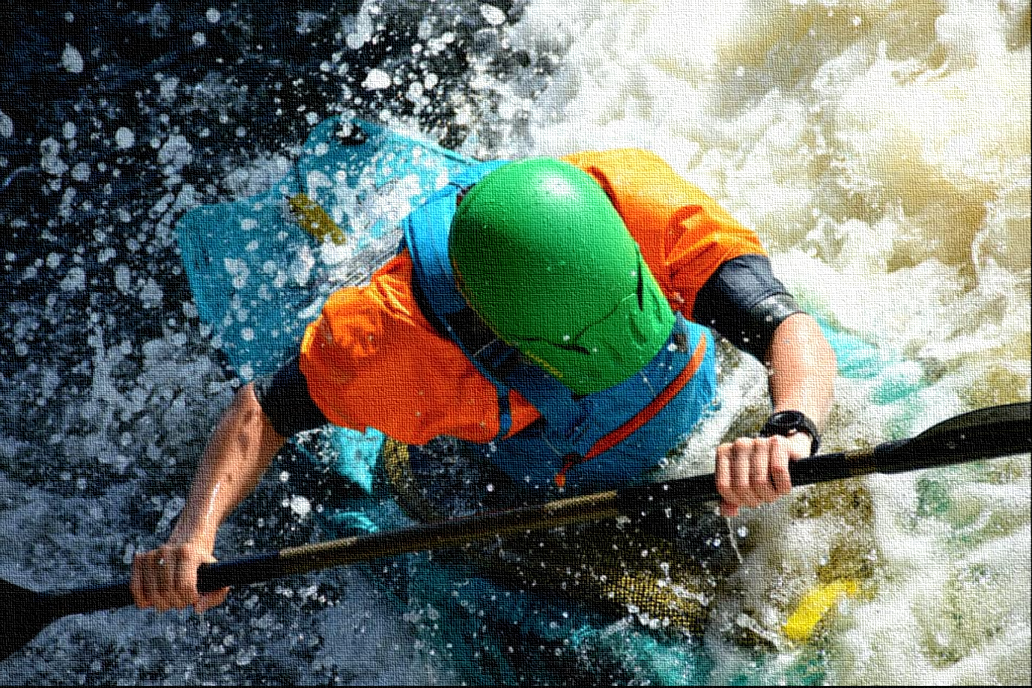

The purpose of the Wombourne Kayak Club Newsletter is to share members’ experiences of river journeys, promote British Canoeing Coaching, Campaigns and news to a wider audience to enable a network of paddlers to share ideas based along the River Severn.

Contents:
- Reflections on recent trips
- Coaching, campaigns and news
- Dates for your diary
- Club notices

Reflections on Recent Trips

River Tryweryn – March 7th 2020

Video - Lower Tryweryn March 7th 2020

David: “Second time on the River Tryweryn lower section”

- What did you learn?
That there's no substitute for running the river. That with more experience on the river, you can relax more, which helps cope with sideways-approaching streams. To check-out the feature beforehand and see the right lines. Don't be too quick to bale out.

2. What were the safety aspects did you need to consider as part of the group?
To assess the features and see if they're "do-able". To put people on the river bank with throw-lines etc. as necessary.

3. What did you think about the Safety Management as part of the group? E.g. CLAP
Good. I felt well taken care-of!
4. What did you enjoy about the experience?
Being pushed to try more difficult features, and mainly succeeding.

5. How did you feel about your second attempt on this section?
More relaxed, which helps with staying loose, as partly mentioned in 1, above. Less intimidated, able to look ahead a bit more.

- What went well?
Coping with the features generally. Getting into eddies and assessing the next section more thoroughly. Reading the river a little better. Running the river a little better.

- What would you do next time?
More of the same. Have a go at the falls at the end.

8. What was different on the River Banwy river trip experience? E.g. “What3words”app.
Coping with low water/rocks, pacing myself. Appreciating signals more, and making use of them.

River Banwy - Upper Section (Llanerfyl-lLanfair-Cereinion) 14th March 2020
Paddlers: Rich, James, John, David A.

Video - River Banwy Part A
Video - River Banwy Part B

James: River Banwy Trip Upper Section

- What did you learn?
CLAP – Communication, Line of Sight, Avoidance, Position of maximum usefulness. Don’t recall coming across this term before.
Demonstration of the “S” turn and surfing.
Demonstration of hugging a rock.
Positioning - point that myself and David a couple of times could have taken up a location in a better positioned eddy so that we could maintain an easier line of sight with Rich and John without being prompted to move.
About the local wildlife, thanks Rich Dowen

- What were the safety aspects did you need to consider as part of the group?
River signals – slightly different from those used before.
Spacing got bunched up a little at times.
River was rocky, few paddlers got stuck at certain points and necessary to eddy up/slow down and monitor whilst they freed themselves. We were in a small group so necessary to look after each other.

- What did you think about the Safety Management as part of the group? E.g. CLAP
Good consideration of safety before the trip. Risk assessment, location and paddlers fed back to the club prior to and after paddling.
Communication on the river was good. Signalling but usually in verbal communication range.
Line of sight – always within view of each other.
Avoidance – river split into left and right channels at two points and we took the safer route as there was a better view of the river.
Positioning – John and Rich generally took up positions at the front and back, looking at the river and offering advice and guidance on safe routes and positioning for myself and David.

- What did you enjoy about the experience?
Confidence building: find paddling a big confidence centric experience. Don’t get the chance to get on moving water as often as I like and rivers like this one offer the chance to practice the skills from the pool sessions without the fear of getting too wet. Was a relaxed paddle with good and open atmosphere, plenty of opportunities to practice at points in the river! Rich and John were demonstrating techniques as we travelled down the river. David’s flapjacks were delicious and almost worth the trip on their own.

- How did you feel about your second attempt on this section?
It was my first time on this river so wasn’t sure what to expect, but really enjoyed it. It’s a great river for beginners and building that confidence.

- What went well?
Felt more comfortable as the trip went on and was able to practice getting into and out of eddies. Making the smaller eddies behind rocks was useful.
- What would you do next time?
Make more use of the opportunities to practise “S” turns shown by Rich and John and perhaps try surfing. Break out where it’s more “choppy”.

- What was different on the River Banwy than your last river trip experience?
No swims!

Coaching, Campaigns and News
Links below:

British Canoeing guidance for clubs to fight corona virus
BC Coaching News:

BC Safety Updates

BC Online Incident reporting use to report incidents such as those with other water users, access issues, pollution/environment, canoeing safety etc as well as major incidents or accidents.

Environmental Agency Consultation document with support material to answer questions for River Severn, any suggests or help contact John

Petition to prevent changes to the laws for access
Clear Access Clear Waters If you want to see fair, shared and sustainable open access to waterways for all then please take a moment to sign this petition
How to Read Whitewater
CLAP : An Acronym For Outdoor Safety

Dates for your diary
March 26th - last Wombourne Leisure Centre Pool Session of 2020
April 2nd – first outdoor Thursday session – Jackfields (level permitting) or local canal
May 4th – 8th Scotland Trip
Club Notices
Jonathan passed his Lea Valley legacy course assessment – well done Jonathan, on to the Olympic course next!
Pool sessions have been well supported, with new and existing members working on core skills such as efficient paddling, changes in direction and rolling

​

